Project Oracle Application

***Technical Specification Document***

***[Invoice Payment Control Tower]***

***Vementor – View Data From Oracle***

v.1, Sep 2020

**PT. Karsa Lintas Buwana**

# Lembar Persetujuan

|  |  |  |
| --- | --- | --- |
|  |  |  |
| User Representative |  | Tanggal ( ) |
|  |  |  |
| Solution Architech |  | Tanggal ( ) |

# Historis Dokumen

| **VERSI** | **DIKELUARKAN PADA** | **KETERANGAN** |
| --- | --- | --- |
| 0.1 | 14 Oct 2020 | Oracle API Program |
| 0.2 |  |  |
| 0.3 |  |  |
|  |  |  |

Daftar Isi

Lembar Persetujuan 2

Historis Dokumen 3

Pendahuluan 5

1.1. DESKRIPSI 5

EDIT KLAIM 6

2.1. FSD DESIGN WEB 6

2.2. FIELD DESCRIPTION 7

2.3. FIELD XXVMT_RFP_INVOICE_RPT_V 8

2.4. FIELD XXVMT_RFP_INVOICE_V 10

# Pendahuluan

## DESKRIPSI

Dokumen ini menjelaskan secara teknis tekait function-function yang perlu ada di system yang merupakan penjabaran/penjelasan dari dokumen FSD dan BRD.

# EDIT KLAIM



## FSD DESIGN WEB

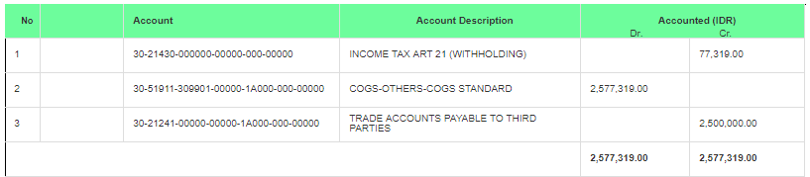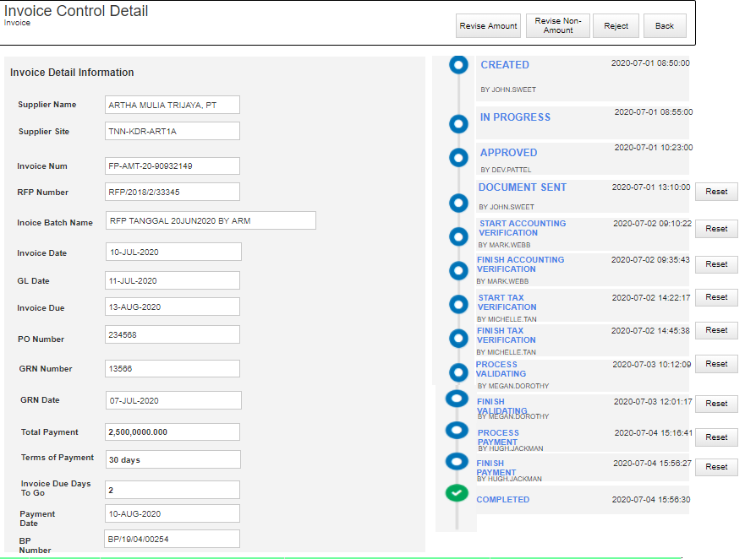

## FIELD DESCRIPTION

|  |  |  |  |  |  |  |
| --- | --- | --- | --- | --- | --- | --- |
| **Field Name** | **Description** | **Mandatory** | **Type** | **Data Type** | **Data** | **Notes** |
| **Invoice Detail Information** | | | | | | |
| Supplier Name | Nama supplier | Yes | Textfield | VarChar | Data ambil dari table Oracle | Disable |
| Supplier Site | Supplier Site | Yes | Textfield | VarChar | Data ambil dari table Oracle | Disable |
| Invoice Num | Invoice Num | Yes | Textfield | VarChar | Data ambil dari table Oracle | Disable |
| RFP Number | RFP Number | Yes | Textfield | VarChar | Data ambil dari table Oracle | Disable |
| Invoice Batch Name | Batch Name deskripsi Invoice | Yes | TextField | VarChar | Data ambil dari table Oracle | Disable |
| Invoice Date | Tanggal Invoice Diterima | Yes | TextField | Date | Data ambil dari table Oracle | Disable |
| GL Date | Tanggal RFP tersebut dibuat | Yes | TextField | Date | Data ambil dari table Oracle | Disable |
| Invoice Due | Tanggal tenggat waktu pembayaran | Yes | TextField | Date | Data ambil dari table Oracle | Disable |
| PO Number | Po Number | Yes | TextField | Number | Po Number dari table Oracle | Disable |
| GR Number | Nomor GRN | Yes | Textfield | Number | Data ambil dari table Oracle | Disable |
| Total Payment | Nominal bayar yang tetera pada RFP | Yes | Textfield | Number | Data ambil dari table Oracle | Disable |
| Terms of Payment | Leadtime pembayaran sesuai dengan PO | Yes | Textfield | VarCHar | Data ambil dari table Oracle | Disable |
| Invoice Due Days to Go | Tenggat hari dari sysdate hingga ke due date pembayaran | Yes | Textfield | VarChar | Perhitungan dari :  Invoice Due – Sysdate | Disable |
| Payment Date | Tanggal pembayaran di bank payment untuk RFP tersebut | Yes | TextField | VarChar | Data ambil dari table Oracle | Disable |
| BP Number | Nomor bank payment | Yes | TextField | VarChar | Data ambil dari table Oracle | Disable |
| **Account Information** | | | | | | |
| No | Nomor Sequence | Yes | Numberfield | Int | Sequence number | Disable |
| Account | Charge of Account yang terbentuk atas PO tersebut | Yes | Numberfield | Int | Data ambil dari table Oracle | Disable |
| Account Description | Deskripsi CoA | Yes | TextField | VarChar | Data ambil dari table Oracle | Disable |
| Accounted (IDR) | Debit and Credit dalam amount | Yes | Numberfield | Int | Data ambil dari table Oracle | Disable |

## FIELD XXVMT_RFP_INVOICE_RPT_V

|  |  |  |
| --- | --- | --- |
| Field | Type | description data |
| rfp_no | varchar2 (150 byte) | Select ab.attribute1 from ap.ap_batches_all |
| supplier_name | varchar2 (360 byte) | Select hp.party_name supplier_name from ar.hz_parties |
| batch_id | number (15) | Select ab.batch_id from ap.ap_batches_all |
| org_id | number (15) | Select ai.org_id from ap.ap_invoices_al |
| invoice_batch_name | varchar2 (50 byte) | Select ab.batch_name invoice_batch_name from ap.ap_batches_all |
| invoice_due | date | Select apsa.due_date invoice_due from ap.ap_payment_schedules_all |
| total_payment | number | Select ai.invoice_amount total_payment from ap.ap_invoices_al |
| paid_to | varchar2 (360 byte) | Select decode (ab.attribute2, null, hp.party_name, ab.attribute2, ab.attribute2) paid_to from ap.ap_batches_all aba, ar.hz_parties |
| requestor | varchar2 (150 byte) | Select ab.attribute3 requestor from ap.ap_batches_all |
| creator | varchar2 (100 byte) | Select fu.user_name creator from fnd_user |
| invoice_amount | number | Select ai.invoice_amount from ap.ap_invoices_al |
| vat_registration_num | varchar2 (20 byte) | Select aps.vat_registration_num from ap_suppliers |
| bank_name | varchar2 (360 byte) | Select ieb.bank_name bank_name from iby_ext_bank_accounts |
| beneficiary_name | varchar2 (80 byte) | Select ieba.bank_account_name beneficiary_name from iby_ext_bank_accounts |
| account_number | varchar2 (100 byte) | Select ieba.bank_account_num account_number from iby_ext_bank_accounts |
| invoice_id | number (15) | Select ai.invoice_id from ap.ap_invoices_al |
| invoice_num | varchar2 (50 byte) | Select ai.invoice_num from ap.ap_invoices_al |
| invoice_date | date | Select ai.invoice_date from ap.ap_invoices_al |
| gl_date | date | Select ai.gl_date from ap.ap_invoices_al |
| exchange_rate | number | Select ai.exchange_rate from ap.ap_invoices_al |
| exchange_date | date | Select ai.exchange_date from ap.ap_invoices_al |
| exchange_rate_type | varchar2 (30 byte) | Select ai.exchange_rate_type from ap.ap_invoices_al |
| invoice_currency_code | varchar2 (15 byte) | Select ai.invoice_currency_code from ap.ap_invoices_al |
| npwp | varchar2 (150 byte) | Select ai.supplier_tax_invoice_number npwp from ap.ap_invoices_al |
| tgl_faktur | date | Select ai.supplier_tax_invoice_date tgl_faktur from ap.ap_invoices_al |
| attribute_category | varchar2 (150 byte) | Select ai.attribute_category from ap.ap_invoices_al |
| description | varchar2 (240 byte) | Select ai.description from ap.ap_invoices_al |
| terms_due_days | number | Select atl.due_days terms_due_days from ap_terms_lines |
| bp_number | varchar2 (150 byte) | Select aca.attribute3 bp_number from ap_checks_all |
| ppn_base_amount | varchar2 (23 byte) | Select to_char (ai.attribute3, '9,999,999,999,999.9999') from ap.ap_invoices_al |
| ppn_amount | varchar2 (21 byte) | Select to_char (ai.attribute4, '999,999,999,999.9999') from ap.ap_invoices_al |
| supplier_site | varchar2 (15 byte) | Select pov.vendor_site_code from apps.po_vendor_sites_all |
| po_num | varchar2 (20 byte) | Select pha.segment1 from po_headers_all |
| po_date | date | Select pha.creation_date from po_headers_all |
| rcv_num | varchar2 (30 byte) | Select rsh.receipt_num from rcv_shipment_headers |
| rcv_date | date | Select rt.transaction_date from rcv_transactions |
| approval_status | varchar2 (4000 byte) | Select ap_invoices_pkg.get_approval_status (ai.invoice_id, ai.invoice_amount, ai.payment_status_flag, ai.invoice_type_lookup_code) from ap.ap_invoices_al |
| approval_by | varchar2 (0 byte) | null |
| approval_date | varchar2 (0 byte) | null |
| validation_status | varchar2 (0 byte) | null |
| payment_date | varchar2 (0 byte) | null |
| date_invoice_received | varchar2 (0 byte) | null |
| project_code | varchar2 (150 byte) | project_code |
| payment_status_flag | varchar2 (1 byte) | Select ai.payment_status_flag from ap.ap_invoices_al |
| approval_status_gl | varchar2 (4000 byte) | Select ap_invoices_pkg.get_approval_status (ai.invoice_id,ai.invoice_amount, ai.payment_status_flag, ai.invoice_type_lookup_code) from ap.ap_invoices_al |

## FIELD XXVMT_RFP_INVOICE_V

|  |  |  |
| --- | --- | --- |
| field | type | description |
| invoice_id | number (15) | select ai.invoice_id from ap.ap_invoices_all ai, gl.gl_code_combinations glcc, ap.ap_batches_all ab |
| rfp_no | varchar2 (150 byte) | select ab.attribute1 rfp_no from ap.ap_batches_all ab |
| currency_code | varchar2 (15 byte) | select ai.invoice_currency_code currency_code from ap.ap_invoices_all ai |
| amount_dr | number | sum (nvl (aid.amount, 0)) amount_dr from ap.ap_invoices_all ai, ap.ap_invoice_distributions_all aid |
| amount_cr | number | select sum (nvl (ai.invoice_amount, 0)) amount_cr, from ap.ap_invoices_all ai, |
| accounted_dr | number | decode (ai.invoice_currency_code, , sum (nvl (aid.amount, 0)), sum (nvl (aid.base_amount, 0))) accounted_dr from ap.ap_invoices_all ai, ap.ap_invoice_distributions_all aid |
| accounted_cr | number | select decode (ai.invoice_currency_code,'idr', sum (nvl (ai.invoice_amount, 0)),sum (nvl (ai.base_amount, 0))) accounted_cr, from ap.ap_invoices_all ai, |
| gl_account | varchar2 (181 byte) | select glcc.segment1  || '-'  || glcc.segment2  || '-'  || glcc.segment3  || '-'  || glcc.segment4  || '-'  || glcc.segment5  || '-'  || glcc.segment6  || '-'  || glcc.segment7  gl_account,  from ap.ap_invoices_all ai,  gl.gl_code_combinations glcc |
| gl_account_description | varchar2 (4000 byte) | select xxvmt_intf_invoice_pkg.gl_code_descr (  glcc.code_combination_id)  gl_account_description,  from ap.ap_invoices_all ai,  gl.gl_code_combinations glcc |
| approval_status_gl | varchar2 (4000 byte) | select ap_invoices_pkg.get_approval_status (  ai.invoice_id,  ai.invoice_amount,  ai.payment_status_flag,  ai.invoice_type_lookup_code)  approval_status_gl  from ap.ap_invoices_all ai |

## Sequence numbering RFP Number

Menambahkan segment kode PT sesuai dengan organisasi di masing –masing Oracle untuk KLB Group (CRM, KHD, KLB, MKT). Namun untuk scope kali ini, pilot project akan dilaksanakan di 1 PT terlebih dahulu yaitu **PT CRM.**

Format RFP Number existing yang disimpan pada attribute1 table **AP_BATCHES_ALL** adalah



Penambahan format tersebut adalah identitas kode PT yang ditambahkan setelah format **RFP/** sehingga format RFP Number menjadi RFP/**CRM**/20/… seperti informasi dibawah ini :

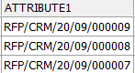

## TSD Sequence numbering RFP Number

Perubahan sequence di report **XXCRM_APRRFP.rdf** pada function **Generate_RFPNo.**

v_temp := 'RFP/CRM/' || TO_CHAR(SYSDATE, 'YY/MM/');